**CENWP-OD-J March 14, 2021**

**MEMORANDUM FOR THE RECORD**

**SUBJECT: 22JDA04 South Fish Ladder Temperatures**

**Background:**

In 2016 John Day Dam, along with other USACE projects, began monitoring and reporting fish ladder temperatures after high river temperatures in the 2015 migratory year contributed to low Sockeye salmon survival. Thermal gradients in adult fish ladders are associated with slowing adult salmon migration (Caudill et al. 2006; USACE 2004) and warmer water temperatures alter salmon behavior.

In 2018 and 2019 a temperature depth profile study was conducted on the lower Columbia River projects to monitor the vertical thermal profile of the forebays next to fish ladder exits to determine if cooler water existed for potential cooling of the fish ladders (Lundell et al 2019). The study concluded that at the John Day Dam forebay near the South fish ladder there was a steeper thermal gradient compared to The Dalles and Bonneville projects. If this cooler water were to be pumped from the bottom it may match the tailwater temperatures at times; however, at The Dalles and Bonneville forebays it may be a negligible endeavor.

This memo is to evaluate ladder temperature differentials in the South fish ladder at John Day Dam (JDA) along with operational recommendations to consider that may be implemented to reduce thermal gradients that could be monitored during adult passage season.

**Method:**

Temperature data has been collected from the JDA South Fish Ladder (SFL) entrance and exit sections since 2011. During this time the readings have been taken from the same locations (See figure 1). JDA uses Onset HOBO temperature loggers (Model: U22-001) that are deployed in 2” PVC pipes mounted to the ladder wall. The pipes are drilled to allow water circulation. The loggers are approximately 1-foot from the ladder floor.

Temperatures are recorded hourly, and data is typically offloaded weekly. Unfortunately, there have been times when weekly readouts weren’t feasible (short staffed, heavy workloads, malfunctioning equipment, etc.) and blocks of data were lost (See Table 1). This makes it more difficult to analyze data during these blocks. Therefore, most of the data is shown as 10-year averages to help offset these lost data blocks.

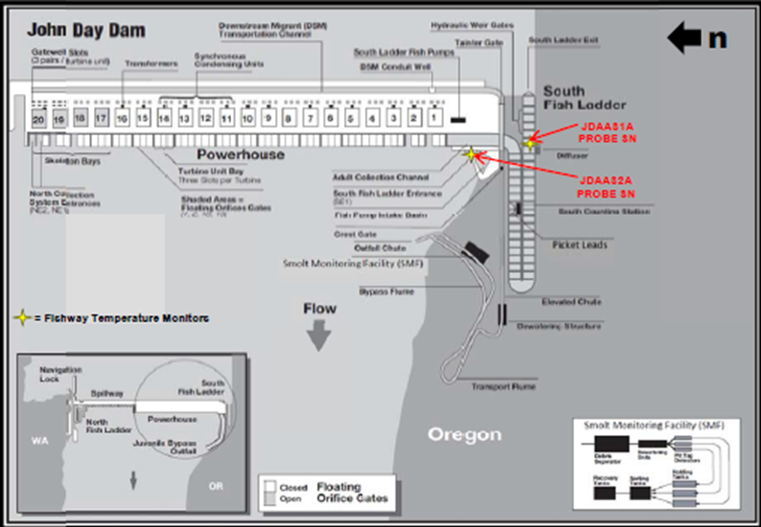

**Figure 1:** Diagram illustrating the locations of the John Day Dam project’s South fish ladder temperature probes.

|  |  |  |  |  |
| --- | --- | --- | --- | --- |
| **2021** | **2020** | **2019** | **2018** | **2017** |
| (5/18 - 8/21) &  (8/30 - 9/21) | 5/1 - 9/23 | 5/1 - 9/16 | (5/1 -6/28) &  (9/6 - 9/26) | 5/1 - 9/27 |
|
| **2016** | **2015** | **2014** | **2013** | **2012** |
| 5/1 - 9/14 | 5/1 - 9/14 | 5/1 - 9/14 | 5/1 - 9/16 | 5/1 - 9/17 |
|

**Table 1:** The timeframes when JDA has temperature data available for the SFL and USGS has temperatures available for the forebay

**Results:**

The SFL exit is typically warmer than the entrance (See Figure 2) and the exit temperatures tend to fluctuate more throughout the day (see Figure 3).

The average 10-year differential between the SFL exit and entrance (when the exit was ≥70°F) was 0.93°F (See Table 2). When the temperature differential is ~1.8°F (1°C) salmonid passage is negatively impacted. Over the course of 10-years, the differential was ≥1.8°F 20.69% of the time (when the exit was ≥70°F). The highest percentage observed was 2015 (30.95%) and the lowest was 2013 (10.17%).

Fish run timing varies year to year and species to species at JDA (See Figure 4). When comparing the 10-year average water temperature to the 10-year average salmonid passage (at JDA) the following overlaps are observed. Steelhead have the highest interaction with warmer ladder temperatures at JDA with 45.0% of the total steelhead run passing when ladder temperatures are ≥70 F°. Sockeye passage has the least overlap with 3.0% passing at temperatures of ≥70 F°. (Chinook = 37.0% and Coho = 34.3%).

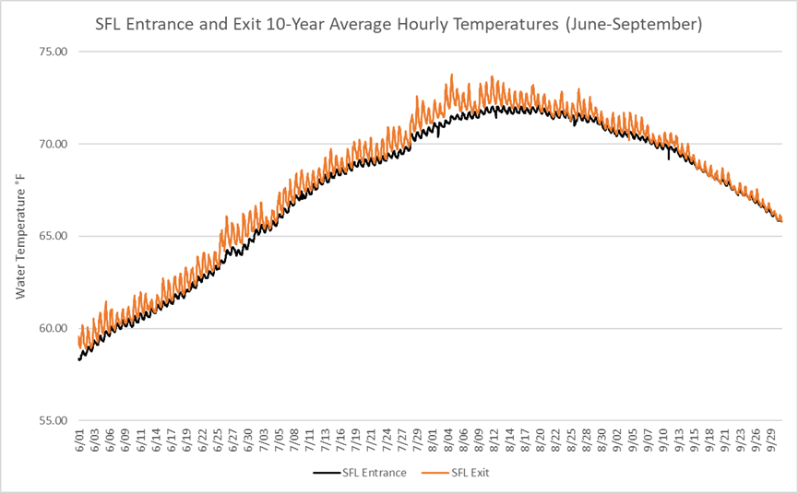

**Figure 2:** The SFL entrance-exit hourly temps shown as a 10-year average (June 1st – September 30th).

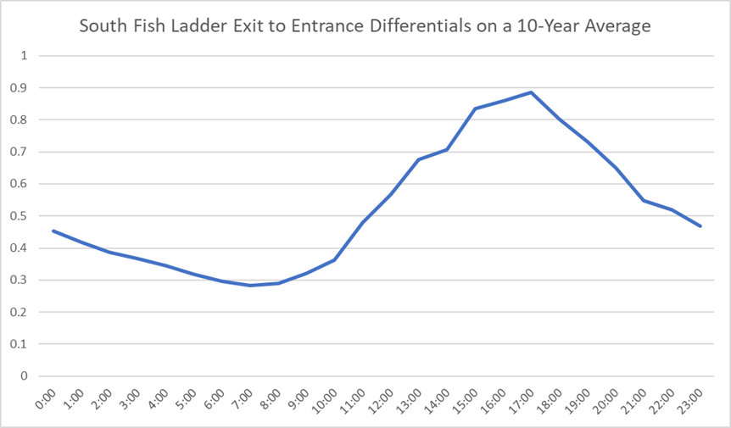

**Figure 3:** Graph illustrating temperature differentials between the SFL exit and the SFL entrance at different times of the day (how many degrees °F the exit is warmer than the entrance). The values are shown as 10-year average temperatures (2012 – 2021) at specific hourly intervals from June 1st – September 30th. 

**Table 2:** Table representing the total number of hours the JDA SFL exit was ≥ 70°F and of those hours, the number of hours the SFL exit was ≥ 1.8 °F (1°C) warmer than the SFL entrance. The percentage represents the time when the SFL exit was ≥ 1.8°F warmer than the entrance (when the SFL exit was ≥70°F). Tables show a 10-year span and are broken up by; June - July, August – September, and both combined (June – September). There are 2,928 hours between June 1st and September 30th.

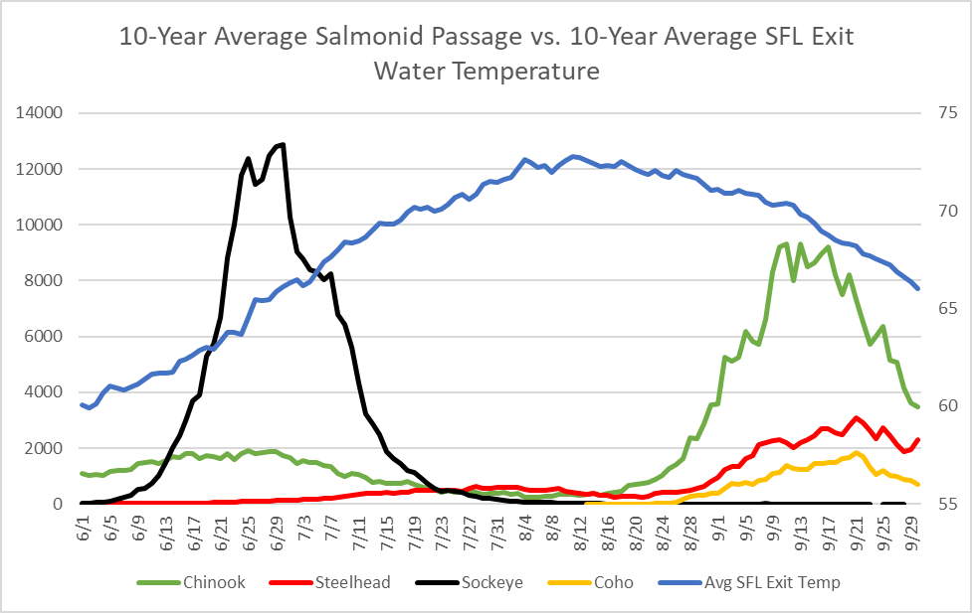

**Figure 4:** The 10-year average (2012 - 2021) for Chinook, steelhead, sockeye, and coho passage at John Day Dam. The secondary axis is the average daily water temperature at the JDA south fish ladder exit.

**Ladder Operations:**

The John Day Dam South fish ladder uses three Francis turbine pumps to supply attraction water for the SFL (See Figure 5). The turbine pumps are supplied by a 5’ penstock located at 200’ msl in the forebay of the dam approximately 90-feet north of the fish ladder exit. The turbine drives a gear box that pumps water from a stilling basin on the downstream side of the dam at 90’ msl. Normal forebay and tailrace operations at JDA are 262.5’ – 266.5’ msl and 159’ – 162.5’. This water is used for attraction flows at the SFL entrances, collection channel flow between the South and North ends of the powerhouse and diffusion chambers in the lower overflow weirs above the transition pool at the base of ladder.

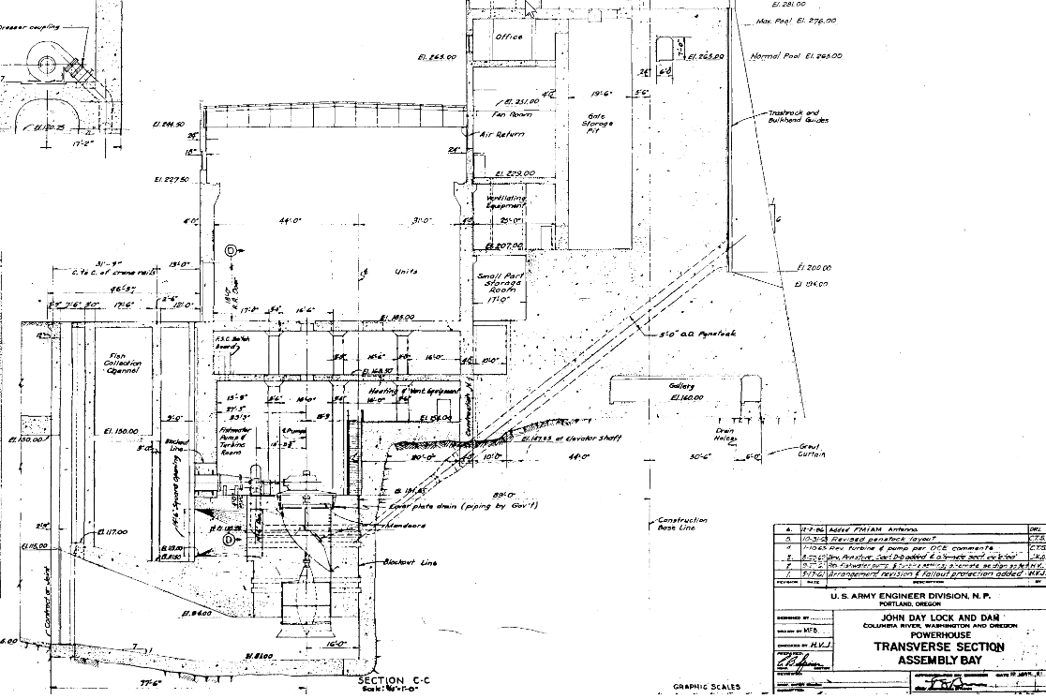

**Figure 5:** Transverse cross section of assembly bay showing SFL fish turbine penstock intake and discharge and pump assembly intake and discharge.

Additionally, water is added to the SFL from diffuser #5 above weir 248 which is the last overflow weir before the start of the exit control section (See Figure 6). The diffuser is fed from two 24” supply lines from a forebay intake at 238’ msl. Actuated butterfly valves automatically adjust flow to the diffuser keeping 1’- 1.3’ of water over the overflow weirs depending on the ladder setting. The level is monitored and adjusted from readings taken between weirs 193 and 194 at the SFL count station. Water flows from diffuser #5 range from 5.5 – 88.1 cfs and vary based on operational setting and forebay elevations (See Table 3). Between June 10th and September 9th, 2019, water temperatures at the diffuser were on average ~0.5°F cooler than surface water temperatures (measured at ~5’ of depth) (Lundell et al. 2019).

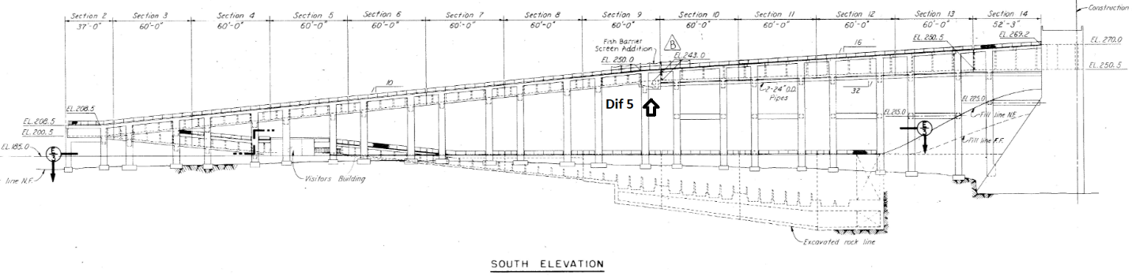

**Figure 6:** General layout of elevation sections including views of Diffuser #5 and 24” supply lines from forebay intake at 238’msl.



Table 3: Ladder flows based on forebay elevation and corresponding sill setting and diffuser flow

Ladder flow starts in the forebay as water passes through the exit into the upper control section of the ladder. The control section is of a vertical slot weir configuration with a 1:32 slope. Adjustable actuated sill gates on weirs 256 – 267 modulate gravity flow from the forebay based on water elevation (See Figure 7).

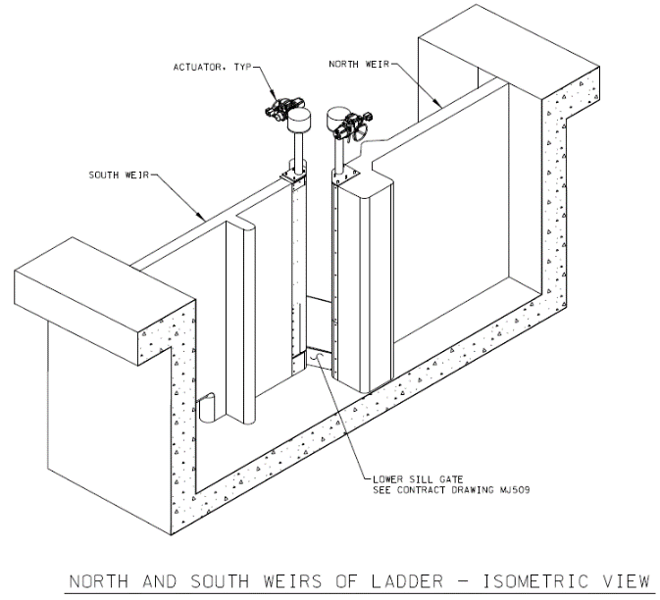

Figure 7: Vertical slot weir with actuated sill gates and orifice in the SFL exit control section.

Operational changes are made to ladder flows during the annual American Shad (shad) run at JDA. Shad have difficulty ascending the ladders through submerged orifices. Once shad passage at Bonneville Dam exceeds 5,000 per day, fish ladders at JDA increase the ladder flow through diffuser #5 at the SFL to 1.3’ over the overflow weirs to aid shad in their passage. Added flows through diffuser #5 can increase by as much as 223% based on the normal operating pool while in the operation for shad passage (See Table4). The 10year average of shad operation at JDA is 54 days and ranged from 22 May to 4 August (See Table4).



Table 4: Operating range of fish ladders at JDA for American Shad at 1.3’ over weirs.

**Conclusion:**

Between June and September, the JDA SFL experiences frequent warm water periods (≥70°F at the SFL exit). During this time the SFL exit is typically warmer than the entrance and differentials >6.5°F have been observed.

Adult salmonids migrating above JDA typically experience different ladder operations between June and July than those migrating between August and September. Within warm water periods, ladder temperature differentials ≥1.8°F (1°C) are typically observed more frequently between August and September (exceptions being 2015 and 2021). The exact impacts this has on SFL salmonid passage are unknown.

**Recommendations:**

More information is needed to better understand ladder temperatures between the ladder exit and entrance locations. JDA project has installed additional temperature probes (See Figure 8) at weir 267 downstream of the fish ladder exit, above and below diffuser #5, at the 180° turn in the overflow weir section, count station, and an additional probe at the entrance area. These probes are in addition to the probes used to report ladder temperatures in the JDA weekly status reports and reported to Fish Passage Center. Forebay string temperatures are not taken at JDA. Project biologists are deploying a string array in the forebay to gather more temperature data of the vertical profile (See figure 9). There is little information on ladder temperatures in the overflow section of the SFL or how different ladder operations could affect temperature gradients.

JDA Proposes a block design study to determine if ladder temperatures in the overflow section can be cooled by switching operations for shad in a 2-day cycle over a two-week period in the beginning of August. The shad operation, on average, is completed by 21 July and the ladder returned to its normal operation of 1’ or water over the overflow weir section. Additional water from the diffuser intake at 238’ msl may help reduce ladder temperatures in the overflow section of the ladder. Such an operation would need to be reviewed and approved in the appropriate regional forum.

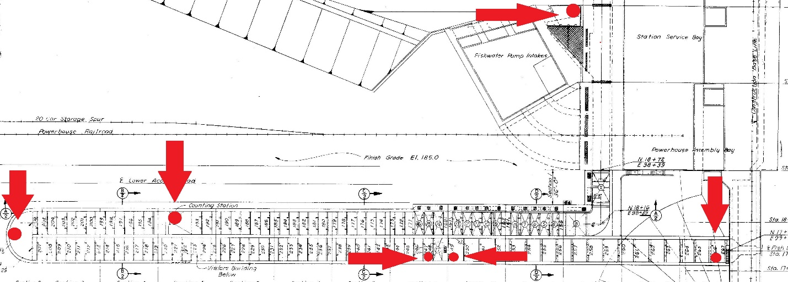

**Figure 8:** Map of the JDA SFL and the location of temperature probes within the ladder.

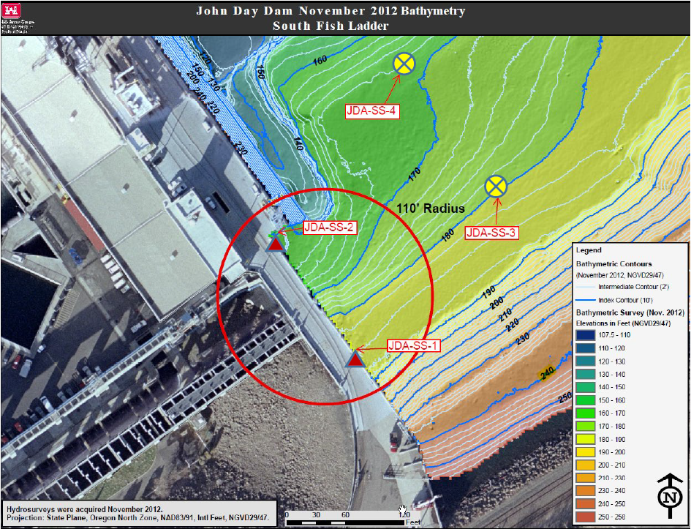

Figure 9: JDA-SS-2 location of array monitoring site.

**References:**

Caudill, C. C., T. S. Clabough, G. P. Naughton, C. A. Peery, and B. J. Burke. 2006. Water temperatures in adult fishways at mainstem dams of the Snake and Columbia rivers biological effects. Technical Report 2006-3. U.S. Army Corps of Engineers, Walla Walla District, Walla Walla, WA.

Fielding, F., E. Grosvenor, M. Lotspeich, L. Ricketts. 2021. 2021 Annual fishways status report. U.S. Army Corps of Engineers, Portland District.

Hydraulic evaluation of lower Columbia River adult bypass systems (HELCRABS). John Day south fish ladder hydraulic/operational evaluation. 2015. U.S. Army Corps of Engineers, Portland District.

Lundell et al. 2019. Lower Columbia River dam forebays temperature depth profile study for 2019. U.S. Army Corps of Engineers, Portland District.